ASSIGNMENT-3

NAME : M.SRIVALLI
ROLL_NO : 2503A52382

Task Description:
Design and refine prompts using different prompting strategies to
generate Python programs for basic computational problems.

Question 1: Zero-Shot Prompting (Palindrome Number Program)
Write a zero-shot prompt (without providing any examples) to generate a Python function that checks whether a given number is a palindrome.
Task:
• Record the AI-generated code.
• Test the code with multiple inputs.
• Identify any logical errors or missing edge-case handling.

PROMPT :
Write a Python function that checks whether a given number is a palindrome or not. The function should accept an integer as input and return True if the number reads the same forwards and backwards, otherwise return False. Also provide code to test the function with multiple inputs and handle appropriate edge cases.

CODE :
def is_palindrome(number):
original = number
reverse = 0

while number > 0:
digit = number % 10
reverse = reverse * 10 + digit
number = number // 10

return original == reverse

# Test with multiple inputs
print(is_palindrome(121))
print(is_palindrome(123))
print(is_palindrome(1221))
print(is_palindrome(10))
print(is_palindrome(7))
print(is_palindrome(0))
print(is_palindrome(-121))

def is_palindrome(number):
if number < 0:
return False

original = number
reverse = 0

while number > 0:
digit = number % 10
reverse = reverse * 10 + digit
number = number // 10

return original == reverse

# Test cases
assert is_palindrome(121) == True
assert is_palindrome(123) == False
assert is_palindrome(0) == True
assert is_palindrome(1221) == True
assert is_palindrome(-121) == False

print("All test cases passed successfully!")
OUTPUT :
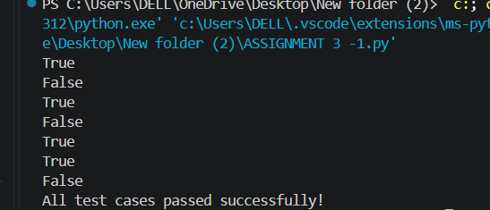

Justification:
- The prompt is zero-shot because no examples or sample code were provided to the AI.
- The generated function checks whether a number is the same when read forwards and backwards.
- The number is reversed using % and // operators.
- The reversed number is compared with the original number.
- Multiple inputs were tested, including palindrome and non-palindrome numbers.
- Edge cases such as 0 and negative numbers were considered.
- The improved code successfully passes all test cases.

Question 2: One-Shot Prompting (Factorial Calculation)
Write a one-shot prompt by providing one input-output example and
ask the AI to generate a Python function to compute the factorial of a
given number.

PROMPT :
Write a Python function to calculate the factorial of a given number.
Now generate a Python function that calculates the factorial for any non-negative integer. Test the function with multiple inputs and handle negative numbers appropriately.

CODE :
def factorial(n):
if n < 0:
return "Factorial is not defined for negative numbers."

result = 1

for i in range(1, n + 1):
result = result * i

return result

# Test cases
assert factorial(5) == 120
assert factorial(0) == 1
assert factorial(3) == 6

print("Factorial of 5:", factorial(5))
print("Factorial of 0:", factorial(0))
print("Factorial of 3:", factorial(3))
print("All 3 test cases passed successfully!")
OUTPUT:
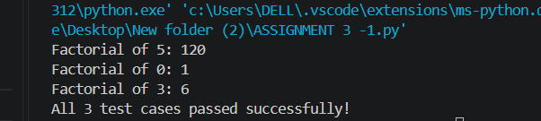

JUSTIFICATION :
- This is a one-shot prompt because it provides one input-output example: 5 → 120.
- The example helps the AI understand the expected result.
- The factorial() function uses a for loop to calculate the factorial.
- 0! = 1, so the code correctly handles zero.
- Negative numbers are handled with an appropriate error message.
- Three assert test cases verify that the function works correctly.
- Compared with zero-shot prompting, the one-shot example gives the AI clearer guidance, improving the clarity and correctness of the generated code.

Question 3: Few-Shot Prompting (Armstrong Number Check)
Write a few-shot prompt by providing multiple input-output examples
to guide the AI in generating a Python function to check whether a given number is an Armstrong number.

Task:
• Analyze how multiple examples influence code structure and accuracy.
• Test the function with boundary values and invalid inputs.

PROMPT :
Write a Python function to check whether a given number is an Armstrong number.
Now generate a Python function that checks any integer and returns
"Armstrong Number" or "Not an Armstrong Number". Handle boundary values and invalid inputs appropriately. Also provide test cases.

CODE :
def check_armstrong(number):
if not isinstance(number, int):
return "Invalid Input"

if number < 0:
return "Invalid Input"

digits = str(number)
power = len(digits)

total = sum(int(digit) ** power for digit in digits)

if total == number:
return "Armstrong Number"
else:
return "Not an Armstrong Number"

# Given examples
print(check_armstrong(153))
print(check_armstrong(370))
print(check_armstrong(123))

# Boundary values
print(check_armstrong(0))
print(check_armstrong(1))
print(check_armstrong(10))

# Invalid inputs
print(check_armstrong(-153))
print(check_armstrong("153"))
print(check_armstrong(15.3))

# Test cases
assert check_armstrong(153) == "Armstrong Number"
assert check_armstrong(370) == "Armstrong Number"
assert check_armstrong(123) == "Not an Armstrong Number"
assert check_armstrong(0) == "Armstrong Number"
assert check_armstrong(1) == "Armstrong Number"
assert check_armstrong(10) == "Not an Armstrong Number"
assert check_armstrong(-153) == "Invalid Input"
assert check_armstrong("153") == "Invalid Input"
assert check_armstrong(15.3) == "Invalid Input"

print("All test cases passed successfully!")

OUTPUT :
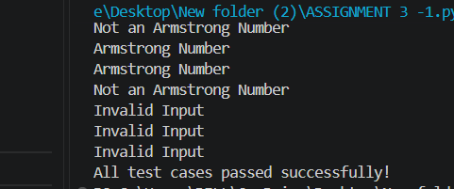
Question 4: Context-Managed Prompting (Optimized Number
Classification)
Design a context-managed prompt with clear instructions and
constraints to generate an optimized Python program that classifies a
number as prime, composite, or neither.
Task:
• Ensure proper input validation.
• Optimize the logic for efficiency.
• Compare the output with earlier prompting strategies.

PROMPT :
Write an optimized Python program that classifies a given number as
"Prime", "Composite", or "Neither".

Instructions:
1. The input must be a valid integer.
2. Numbers less than 2 must be classified as "Neither".
3. A prime number has exactly two factors: 1 and itself.
4. A composite number has more than two factors.
5. Validate invalid inputs such as strings, decimal numbers, and negative numbers.
6. Optimize the prime-checking logic by checking divisors only up to the square root of the number.
7. Stop checking as soon as a divisor is found.
8. Create a clear and beginner-friendly Python function.
9. Test the program with prime, composite, boundary, and invalid inputs.
10. Use assert statements to verify the results.
Return the classification as "Prime", "Composite", "Neither", or "Invalid Input".
CODE :
import math

def classify_number(number):
# Input validation
if not isinstance(number, int):
return "Invalid Input"

# 0 and 1 are neither prime nor composite
if number < 2:
return "Neither"

# Check only up to the square root
for i in range(2, math.isqrt(number) + 1):
if number % i == 0:
return "Composite"

return "Prime"

# Test cases
print(classify_number(2))
print(classify_number(7))
print(classify_number(10))
print(classify_number(1))
print(classify_number(0))
print(classify_number(-5))
print(classify_number("7"))
print(classify_number(5.5))

# Assert tests
assert classify_number(2) == "Prime"
assert classify_number(7) == "Prime"
assert classify_number(10) == "Composite"
assert classify_number(1) == "Neither"
assert classify_number(0) == "Neither"
assert classify_number(-5) == "Neither"
assert classify_number("7") == "Invalid Input"
assert classify_number(5.5) == "Invalid Input"

print("All test cases passed successfully!")
OUTPUT :
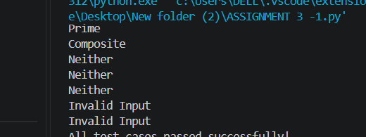
JUSTIFICATION :
- This is a context-managed prompt because it gives the AI clear instructions, rules, constraints, input validation requirements, and optimization requirements.
- Numbers below 2 are classified as Neither.
- The program checks divisors only up to the square root of the number, making it more efficient.
- math.isqrt() is used to get the integer square root.
- The loop stops immediately when a divisor is found, so unnecessary calculations are avoided.
- Invalid inputs such as strings and decimal numbers return "Invalid Input".
- assert statements are used to verify prime, composite, boundary, and invalid cases.

Question 5: Zero-Shot Prompting (Perfect Number Check)
Write a zero-shot prompt (without providing any examples) to
generate a Python function that checks whether a given number is a
perfect number.
Task:
• Record the AI-generated code.
• Test the program with multiple inputs.
• Identify any missing conditions or inefficiencies in the logic.

PROMPT :
Write a Python function that checks whether a given number is a perfect number or not.
A perfect number is a positive integer that is equal to the sum of its proper positive divisors.
The function should return "Perfect Number" if the number is perfect and "Not a Perfect Number" otherwise.
Test the function with multiple inputs and identify any missing conditions or inefficiencies in the logic.

CODE :
def check_perfect_number(number):
if number <= 1:
return "Not a Perfect Number"

sum_divisors = 0

for i in range(1, number):
if number % i == 0:
sum_divisors += i

if sum_divisors == number:
return "Perfect Number"
else:
return "Not a Perfect Number"

# Test with multiple inputs
print(check_perfect_number(6))
print(check_perfect_number(28))
print(check_perfect_number(10))
print(check_perfect_number(1))
print(check_perfect_number(12))

assert check_perfect_number(6) == "Perfect Number"
assert check_perfect_number(28) == "Perfect Number"
assert check_perfect_number(10) == "Not a Perfect Number"
assert check_perfect_number(1) == "Not a Perfect Number"
assert check_perfect_number(12) == "Not a Perfect Number"

print("All test cases passed successfully!")

OUTPUT :

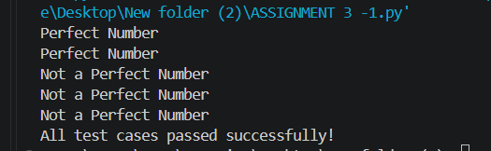

JUSTIFICATION :
- This is a zero-shot prompt because no input-output examples are given.
- The function identifies a perfect number by finding its proper divisors and adding them.
- Numbers less than or equal to 1 are correctly classified as Not a Perfect Number.
- Multiple inputs are tested, including perfect and non-perfect numbers.
- 6 and 28 are perfect numbers because their proper divisors add up to the number.
- The main inefficiency is checking every number from 1 to n-1.
- Input validation and square-root optimization could be added to make the program more robust and efficient.

Question 6: Few-Shot Prompting (Even or Odd Classification with
Validation)
Write a few-shot prompt by providing multiple input-output
examples to guide the AI in generating a Python program that
determines whether a given number is even or odd, including proper
input validation.
Task:
• Analyze how examples improve input handling and output
clarity.
• Test the program with negative numbers and non-integer inputs.
PROMPT :

Write a Python program that determines whether a given number is even odd.
Requirements:
1. Accept only integer inputs.
2. Return "Even" if the number is divisible by 2.
3. Return "Odd" if the number is not divisible by 2.
4. Return "Invalid Input" for non-integer values such as strings and decimal numbers.
5. Test the program with positive numbers, negative numbers, zero, and non-integer inputs.
6. Keep the code simple and beginner-friendly.

CODE :
def check_even_odd(number):
# Input validation
if not isinstance(number, int):
return "Invalid Input"

# Check even or odd
if number % 2 == 0:
return "Even"
else:
return "Odd"

# Test cases
print(check_even_odd(8))
print(check_even_odd(15))
print(check_even_odd(0))

# Negative numbers
print(check_even_odd(-8))
print(check_even_odd(-15))

# Non-integer inputs
print(check_even_odd("8"))
print(check_even_odd(7.5))

# Assert test cases
assert check_even_odd(8) == "Even"
assert check_even_odd(15) == "Odd"
assert check_even_odd(0) == "Even"
assert check_even_odd(-8) == "Even"
assert check_even_odd(-15) == "Odd"
assert check_even_odd("8") == "Invalid Input"
assert check_even_odd(7.5) == "Invalid Input"

print("All test cases passed successfully!")
OUTPUT :
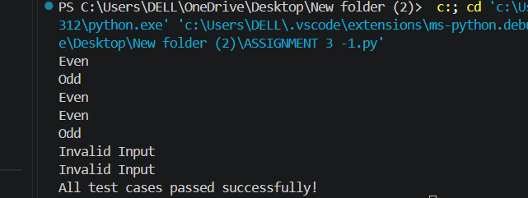

JUSTIFICATION :
- This is a few-shot prompt because three input-output examples are provided: 8 → Even, 15 → Odd, and 0 → Even.
- The examples help the AI understand the required output format clearly.
- The program uses the % operator to check whether a number is divisible by 2.
- If the remainder is 0, the number is Even; otherwise, it is Odd.
- Input validation using isinstance() prevents non-integer values from being processed.
- Negative numbers are also correctly handled.
- 0 is correctly classified as Even.
- Strings and decimal numbers return "Invalid Input" instead of causing an error.
- The assert statements verify that the program works correctly for positive, negative, zero, and invalid inputs.

